NOTE: This software base on Microsoft .NET Framework 3.5, if this software run abnormal, please install Microsoft .NET Framework 3.5 first.

- run autorun.exe
- install PC Manger
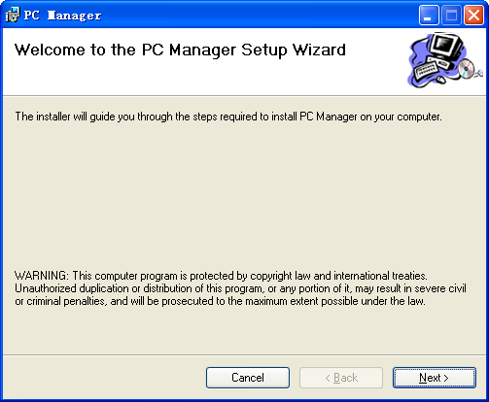
- next
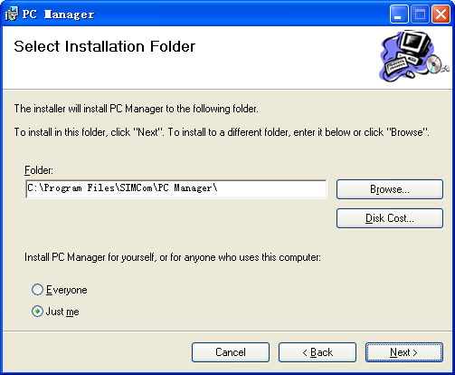
- next
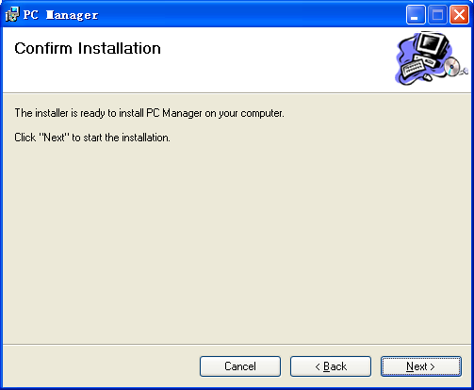
- finish
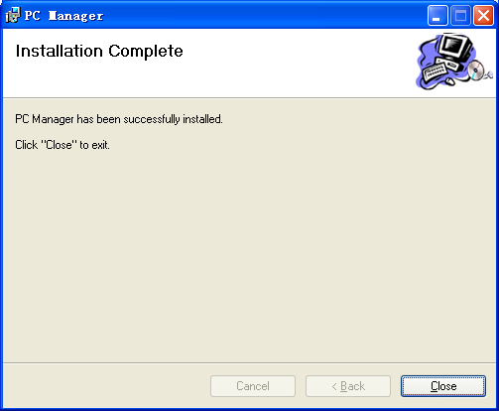
- Module Poweron and connect to PC
- select “android phone”in device manager
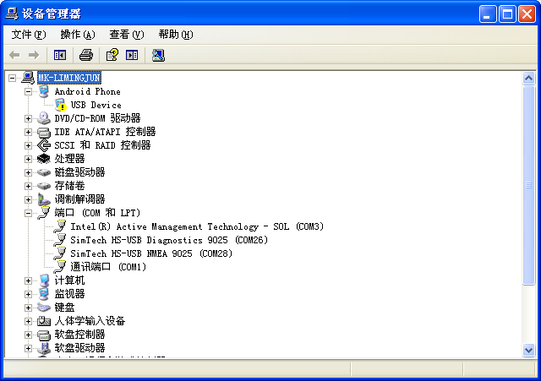
- select next
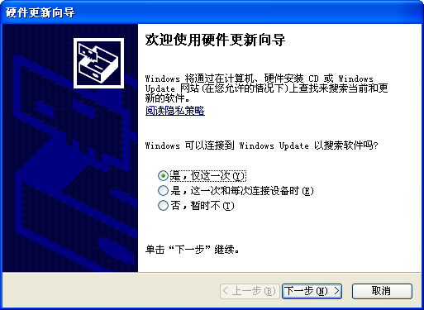
- next
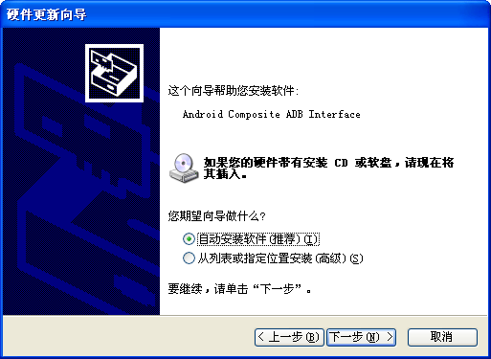
- finish
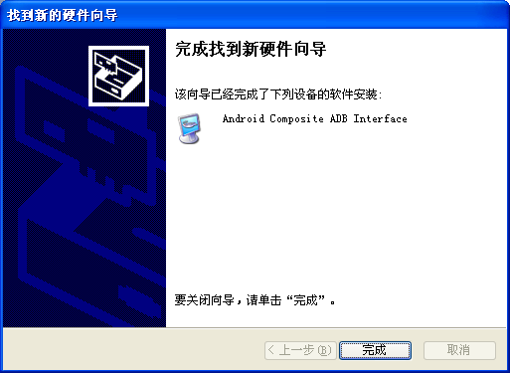
- There is a file named “ConnectType.ini” under install program path. You can use AT command by set Connect Type=AT or use wireless HS-USB Ethernet Adapter device by set Connect Type=NDIS. But under WIN XP, you can only use AT command even if you set Connect Type=NDIS. We can’t support use wireless HS-USB Ethernet Adapter device under WINXP
- open PC Manager.exe

NOTE: If you use AT command, be sure restart your module when changed to use NDIS.

